**I.Overview**

* The rate of flights canceled by weather continuously changing weather over the years:
  + Incresed during the period :2009-2011 (0.57% -> 0.90%)
    - * + Decreased during the period 2011-2012 (0.90% -> 0.55%)
        + Incresed during the period 2012-2014 (0.55% -> 1.05%)
        + Decreased during the period 2014-2016 (1,05% -> 0.61%)
        + Incresed during the period 2016-> 2018 (0.61 -> 0.86%)

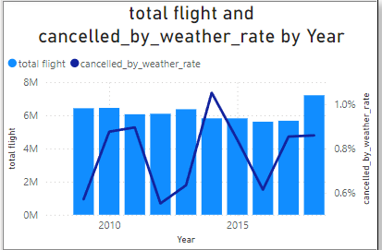

* Most regions had the highest rate of flights canceled due to weather in 2014

(average 1.05%)

* Regions with stable weather throughout the year: Northwestern (0.34%) and Southwestern (0.38%)
* Regions with bad weather in winter. ( month 12,1,2) :
  + Northeast ( Yearly cancellation rate: 1.25% - Cancellation rate in December, January, February: 2.82%)
  + High Plains( Yearly cancellation rate: 0.73% - Cancellation rate in December, January, February 12,1,2 : 1.52%)
  + Ohio Valley ( Yearly cancellation rate: 0.99% - Cancellation rate in December, January, February 12,1,2 : 2.1%)
  + Southeast ( Yearly cancellation rate: 0.73% - Cancellation rate in December, January, February 12,1,2 : 1.54%)
  + Southern ( Yearly cancellation rate: 0.91% - Cancellation rate in December, January, February 12,1,2 : 1.55%)
* The humid subtropical regions (Southeast and Southern) also have an increased rate of flight cancellations due to weather in August and September
* The region with the highest cancellation rate is the Northeast (1.27%), while the region with the lowest rate is the Southwestern (0.41%)
* For flights with both departure and destination points in the Southwestern region, only the Southwestern -> Southwestern route is among the most frequently canceled flights, while other routes are among the least canceled. (The 10 least canceled flight routes all involve the Southwestern region)

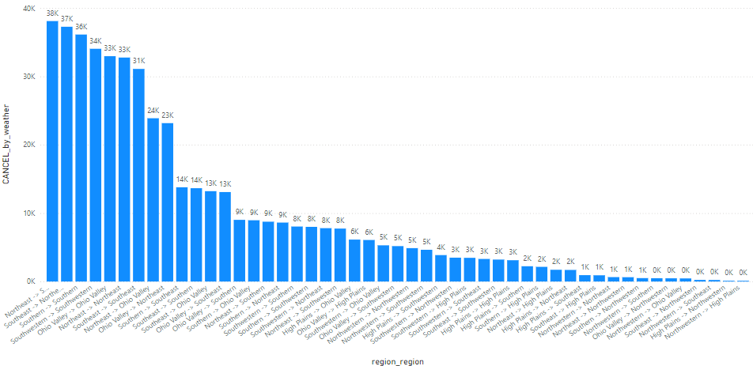

* Flight routes with both departure and destination points in the Northeast region show similar trends in the increase or decrease of cancellation rates over time -> suggesting that weather issues affecting flight routes may originate from the Northeast region

|  |  |
| --- | --- |
| Origin = Northeast | Destination = Northeast |

* Most states with the highest number of flights canceled due to weather have airports that are among the top airports for weather-related cancellations, except for Florida. Florida is ranked 4th in terms of the number of cancellations, but its airports are all ranked 20th or lower
* States with the highest number of flight cancellations each have one airport that significantly influences the state's overall cancellation rate: Texas has DFW Airport with 48%, Illinois has ORD Airport with 75%, and Georgia has ATL Airport with 92%

* DFW Airport is significantly affected by airline MQ, which ranks 4th in terms of flight cancellations and contributes over 30% of DFW’s cancellations. Between 2009 and 2015, DFW Airport was ranked 2nd or 3rd in terms of the number of flight cancellations. However, after MQ ceased operations in 2016, DFW’s ranking improved to 6th in 2016 and 12th in 2017

|  |  |
| --- | --- |
| 2012 | 2017 |

However, when MQ resumed operations in 2018, DFW Airport returned to being among the top 4 airports for the number of flight cancellations

**II. Insight**

1. **Is it possible that flight cancellations are entirely due to factors at the departure point?**

* LAS airport
* Throughout the year, the airport has a cancellation rate of 0.24%, which is lower than the average cancellation rate of 0.77% for airports. Additionally, the cancellation rate for flights arriving at major airports with significant weather issues is higher compared to other airports

* + In January, February, and December, the difference is even greater, with the airport's cancellation rate being 1.06% compared to the average of 0.52% versus 1.58%. The cancellation rate for flights arriving at major airports also differs significantly from that of other airports
    - LAS -> DFW : 1.27%
    - LAS -> ATL : 0.89%
    - LAS -> LAX, SLC, PHX : 0.13%

* **PHX airport** 
  + In January, February, and December, flights departing from this airport to airports with high cancellation rates also have a higher cancellation rate compared to flights to other airports**A screenshot of a computer

    Description automatically generated**
* **DFW airport**
  + This is a major airport with a high cancellation rate, but when flying through other major airports, the cancellation rate is also higher compared to flying to smaller airports that are less affected by weather

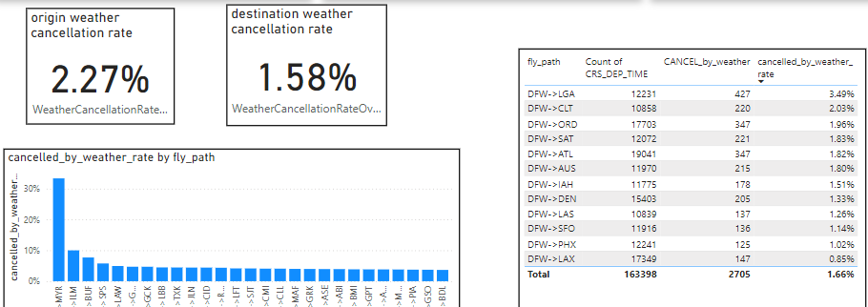

**Conclusion:**

**Destinations with high weather-related cancellation rates also contribute to flight cancellations, not just the departure airports.**

1. **Are the cancellation rates of airlines influenced by airports, or do airports' performance affect airlines?**

**About airport and op_carrier**

* DFW airport :
* American Airlines (AA) accounts for 59.1% of the flights, and with a weather-related cancellation rate of 1.92% (compared to 1.68% on average), approximately 50% of the weather-related cancellations at this airport are caused by this airline. 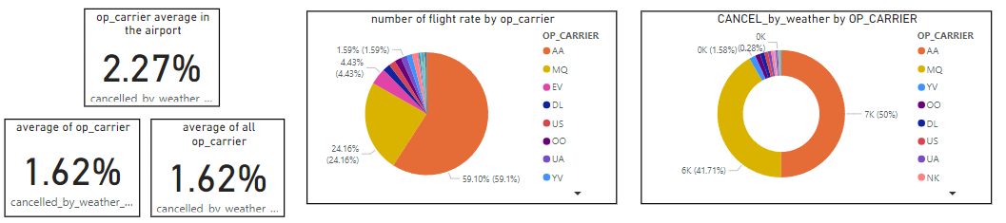
* MQ Airlines accounts for 24.16% of the flights but represents 41.71% of the weather-related cancellations, as its cancellation rate is 3.92% at this airport (compared to the average of 3.80%)A pie chart with different colored circles

  Description automatically generated
* Major airlines generally have higher cancellation rates at this airport compared to their average rates, indicating a high cancellation rate for the airport itself
* ORD airport
  + The airline with the highest number of flights is UA (21.28%), but it ranks fourth in terms of the number of cancellations (15.05%), with a cancellation rate of 1.79%
  + The airline with the highest number of cancellations is MQ (33.54%), with a cancellation rate of 4.08%
  + The top 4 airlines at this airport all have cancellation rates higher than the average for airlines, ranging from 0.32% to 1.34%

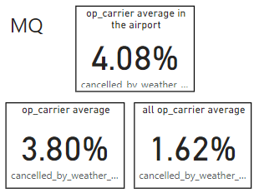

* The airport has poor weather conditions, which have a significant impact, especially on airlines that operate frequently at this airport
* LGA : airport
  + No airline at this airport stands out as much as Delta (DL) at ATL or American Airlines (AA) at DFW. Delta operates the most flights here, accounting for 27.19%, followed by American Airlines at 20.44% and MQ at 13.05%. Consequently, the top airlines are affected by weather-related cancellations almost equally A close-up of a chart

    Description automatically generated
  + Airlines operating at this airport have higher cancellation rates compared to the average for airlines
* DL 3.11% compare to 1.31%
* AA 3.27% compare 1.68%
* MQ 4.68% compare 3.8%
* US 4.17 % compare to 1.47%2
* The airport has poor weather conditions that heavily impact the performance of the airlines
* DL op_carrier
  + Delta (DL) operates a significant number of flights at ATL (39.06% of flights) and MSP (9.27% of flights)
  + The weather-related cancellation rate for this airline is low because most of its flights are at ATL and MSP, where the airline's cancellation rates are also low, thus reducing the overall cancellation rate for the airline

* + - ATL airport

* + - MSP airport
* While the airline's overall cancellation rate is low, it significantly increases when the airline operates at LGA and EWR airports

* MQ carrier
  + It is an airline with a high cancellation rate (3.80%) and also operates many flights at major airports
  + In the Ohio Valley region, the airline has a higher cancellation rate at ORD compared to CMH

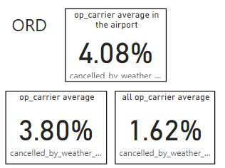

* AA op_carrier
  + It is the third airline in terms of total number of flights in January, February, and December, with a cancellation rate of 2.00
  + In a region with a high cancellation rate like the Northeast (2.79%), the airline still has airports where its cancellation rate is lower than the average

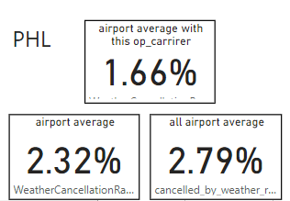

**Conclusion :**

* **Airports in regions with poor weather have a greater impact on airlines compared to airports in regions with extreme weather conditions.**
* **Within the same region, major airports often have a more significant impact on airlines.**

1. **Recommendation**

* Airlines can focus on operating at airports with lower cancellation rates to minimize disruptions.
  + For example, US Airlines focuses its operations at CLT and PHX airports because these are the two airports it uses most frequently and also have the lowest cancellation rates.

* If airports are not within the airline's primary operating area, the airline can look for airports within the region that are less affected by disruptions.
  + For example, MQ Airlines should consider alternative airports such as XNA instead of DFW in the Southern region, and CMH instead of ORD in the Ohio Valley region

* For airports with high cancellation rates, it is advisable to adjust flight schedules to avoid times with adverse weather conditions
  + For example, at DFW Airport, flights should be scheduled between 8 AM and 2 PM, as the cancellation rate is lower during this time compared to other hours

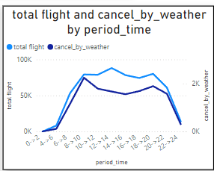

* + In the Ohio Valley region, flights should be scheduled between 8 AM and 12 PM

